BULGING DISC, HARNIATED DISC,
SLIPPED DISC, RUPTURED DISC

Healing Place Health Shop, 2-3 Mander Square, 01902 276468
Slawomir Gromadzki: healingplace77@gmail.com

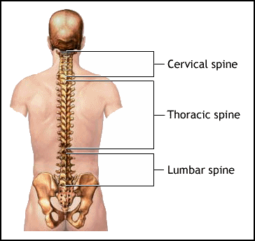
A herniated (bulging) disc is one of the most common causes of neck, back and leg pain (sciatica). 1 in 3 people currently suffer from herniated disc and most of them are unaware of it as pain is not always present.
Spinal disc herniations are particularly common in people between the ages of 35 and 45 who are carrying excess body weight and people who engage in physically challenging occupations that require bending and twisting movements.
Herniated discs most frequently occur in the lower part of the spine; however they can also occur in the cervical and thoracic spine.
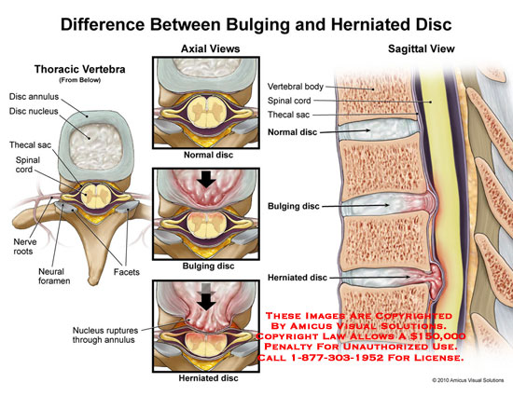
First of all, it is important to understand the key causes of disc herniation.
Below you will find links to short videos which explain it in a clear and simple way:

http://www.spine-health.com/video/herniated-disc-video
http://www.spine-health.com/video/thoracic-herniated-disc-video

A spinal disc consists of a gel centre (nucleus pulposus) surrounded by a tough exterior called the annulus fibrosus. This construction allows the disc to absorb shock while maintaining structural integrity.
Unfortunately, age, trauma, strenuous physical activity, psychological stress, toxins, free radicals, dehydration, unhealthy diet (high in fat and refined sugar), insufficient consumption of raw vegetables and fruits, nutritional deficiencies, genetical predispositions, overweight, lack of physical activity, and other factors can cause the annulus fibrosus to wear down, leading to herniation of the disc’s gel.
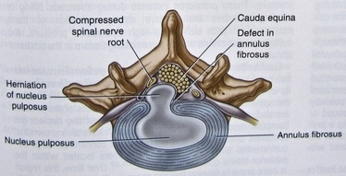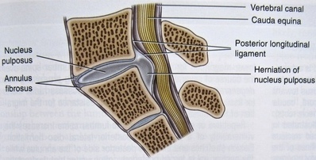
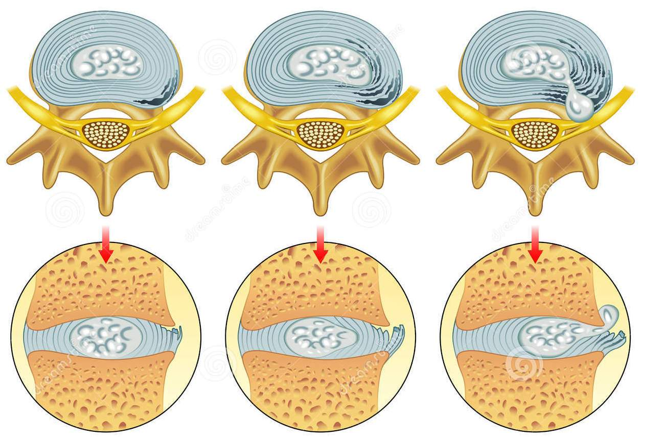
A herniated disc occurs when pressure from the vertebrae above and below (caused by being overweight, inappropriate posture, lifting heavy things, etc.) forces nucleus pulposus (spinal gel) through a weakened or torn apart annulus.
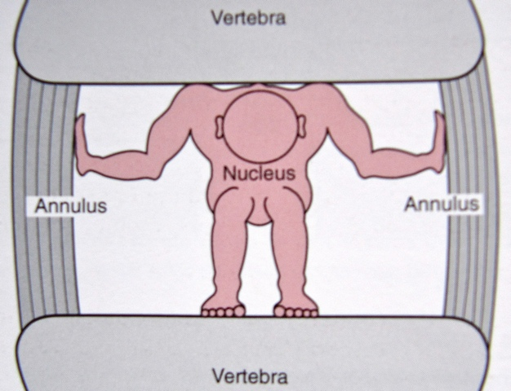
As a result the herniated (slipped) nucleus pulposus can press on the nerves located near the disc, resulting in irritation, inflammation, swelling of the nerve and pain.

It is said that the annulus fibrosus does not repair itself and that scar tissue may eventually form, but it will never be as strong as the original outer ring of the disc. Fortunately, it is not true as human organism has amazing abilities to regenerate itself but the final result depends on the quality of the building material (nutrients) from food we eat. All listed below natural remedies (combined with healthy diet and proper exercises) will eventually lead to complete regeneration of the damaged annulus fibrosus and regression of slipped disc symptoms.

It is also important to be aware of the fact that herniated disc causes chronic inflammation and swelling of the irritated nerve tissue. Anti-inflammatory medicines such as aspirin, ibuprofen, and naproxen block the enzymes that trigger both swelling and pain but they cause bad side effects and thus should be avoided.
Fortunately, there are natural alternatives (listed below) that are very effective in treating chronic inflammation but without harmful side effects. If possible all or most of them should be used at the same time for the optimal and quicker results. Using these remedies will eliminate inflammation, swelling, and pain while at the same time it will gradually lead to regeneration of the damaged annulus fibrosus through which the disc gel slipped outside. The regeneration of the damaged annulus fibrosus will slowly push the spinal gel back to its original place leading to complete recovery.
As soon as the inflammation and pain are under control you should start special exercise program (using the YouTube links listed below) as it will greatly speed up the whole process.

SUPPLEMENTS, SUPER GRASSES, AND HERBAL REMEDIES

- Chlorella: 3 tabl (or 1 teaspoon of powder) 30 min before breakfast and 1 tabl 30 min before lunch with vegetable juice or water. Every day increase dosage by 1 tabl until 10 tabl (or 1 heaped tablespoon) 30 min before breakfast and 7 tabl 30 min before lunch (always with 2-3 glasses of water or vegetable juice).
Chlorella is regarded as the best natural energy booster, detoxifier, pain reliever, and regenerating agent. It is a highest source of nucleic acids RNA and DNA which are capable of repairing damaged DNA. Chlorella together with other supplements and herbal remedies will slowly rebuild the annulus fibrosus which is the key cause of the herniated disc. Since chlorella is 10 times higher in chlorophyll than green leafy vegetables it is best possible oxygen pump in human body. In case of bulging disc it is extremely important as one of the main problems about discs healing is that they do not receive proper supply of oxygen. You can also increase the oxygen level through walking.

- Raw Reserve (Amazing Grass): 1 teaspoon of the powder 30 min before breakfast with vegetable juice or water and 1 teaspoon 30 min before lunch. It can be taken together with chlorella.
Raw Reserve has similar benefits as Chlorella but it has many different ingredients. It is a complete raw food with powerful antioxidants, herbs, super grasses, vitamins and minerals. It is a blend of raw and high-quality, nutrient dense ingredients from the land, fresh water, and the sea with 25 billion probiotics per serving and digestive enzymes to aid digestion and absorption.

- Boswellia (Viridian) 270mg of Boswellia in 1 caps. (65% boswellic acid) (Anti-inflammatory, pain reliever, etc.): 2 times a day 1 caps between meals.

- Turmeric (standardised, Natures aid): 1 caps 2 times a day. Benefits of turmeric: Anti-inflammatory, pain reliever, anxiety, depression, improves mood, detoxifies the body, and kills cancer stem cells.

- Serrapeptase 80.000 IU (Natures aid): 2 times a day 2 caps on an empty stomach. The Miracle Enzyme - Most effective natural pain-killer (without side effects), also removes dead tissue and inflammation (inflammation is a major player in many chronic pain conditions).
After using Serrapeptase 250.000 IU - 1 caps two times a day:

- Vitamin B12 (must be sublingual and only in the form of methylcobalamin, not cyanocobalamin): 2000mcg (2 tablets) a day under tongue at mealtime. Methylcobalamin can reverse neurological damage, detoxify the body, and improve memory and concentration. It will help to regenerate the spinal nerve injury and eliminate pain.

- Vitamin D3 (drops, Natures Answer) - 5 drops a day with meal (10.000 IU a day).
The most important way of obtaining vitamin D is of course through regular sun exposures during summer time between 10am and 2pm. Unfortunately, since in the UK almost every person is deficient in vitamin D the only solution seems to be supplementation.
Vitamin D deficiency plays important role in the development of disc degeneration and herniation. According to a 2014 study, because of the “inflammatory nature of disc herniation and the immunomodulatory effects of vitamin D, as well as the existence of vitamin D receptors in various parts of areas that are affected in the process of disc herniation, vitamin D3 plays important role in reducing the severity of discogenic pain.”
Vitamin D has properties that defend against cell injury caused via free radicals and it affects detoxification pathways which are of importance in disc cell nutritional balance.
Vitamin D also affects sensory neurons to modulate pain, influences neuron excitability and acts at the level of substantia gelatinosa and spinal ganglion in the process of sensory perception.
Apart from having anti-inflammatory properties vitamin D is essential in helping your body to properly absorb and use calcium which helps to keep spine strong. Without vitamin D, our body begins to robe the spine of calcium.
Since vitamin D supplements lead to magnesium deficiency, and because according to recent studies almost every in the UK person is now deficient not only in vitamin D but also magnesium, you must take 400 to 800mg of good quality magnesium every day.

- Magnesium citrate (powder, Viridian): 1 flat teaspoon (800mg) between meals with water.

- Three Tulsi tea (Holy Basil): 2 times a day 1 glass between meals (anti-inflammatory, anxiety, stress, pain reliever, sedentary).

REBUILDING ANNULUS FIBROSUS

The most important goal in treating herniated disc is to regenerate the damaged annulus fibrosus through which the disc gel slips.
In order to figure out how to rebuild it we need to know its building material. The annulus fibrosus consists of water (65–90%) several layers of fibrocartilage made up of collagen (50–70% dry weight), proteoglycans (10–20% dry weight) and noncollagenous proteins (e.g. elastin).

HYDRATE ANNULUS FIBROSUS WITH WATER!
- Studies have shown that the majority of patients with herniated (bulging) disc have loss of water content of the disc with resulting loss of disc height and thus greatly contributed to disc herniation!
Since annulus fibrosus consists mainly of water (65–90%) you need to drink 2-3 litres of water a day (3 -4 glasses 3 times a day between meals). If you drink vegetable juices you need less water.
If possible drink only water low in calcium (not more than 20ml of calcium per litre of water) as calcium in hard water (high in calcium) is inorganic (calcium carbonate) and can’t be absorbed by bone cells and as a result it tends to accumulate in other parts of the body contributing to many health problems.

REGENERATING COLLAGEN
One of the most important goals in treating bulging disc is to rebuild collagen as apart from water it is the second key component of annulus fibrosus. In order to achieve this goal you need especially the following components: glucosamine, omega 3, vitamin C, and MSM (sulphur).

- Glucosamine hydrochloride – 1000mg with meal.
Found naturally in the body glucosamine is essential for the maintenance and repair of collagen (the primary component of discs). The body uses glucosamine to form the chemicals it needs to repair cartilage, tendons and ligaments, and synovial fluid (the naturally occurring fluid that bathes the spinal joints). Collagen helps to maintain and repair spinal joint cartilage.
Should you use glucosamine hydrochloride or glucosamine sulphate?
The active ingredient in any glucosamine product is only the glucosamine element, and the hydrochloride or sulphate acid salt is purely a delivery vehicle. The simple answer is that both forms are equally effective. However, the glucosamine sulphate is stabilised with sodium chloride (table salt) – and can contain as much as 30% sodium which contributes to high blood pressure and other problems. For this reason hydrochloride is a better way to go.
Should you use glucosamine with chondroitin?
No. A number of glucosamine products include chondroitin (a cattle-sourced compound) and many believe that they should be used together for better results. This idea, however, is misleading as chondroitin can be beneficial only in the form of direct injections to the affected part of the body. As an orally-taken compound, chondroitin doesn’t make sense because it is essentially destroyed during the digestive process. Scientific evidence does not show that a glucosamine-chondroitin combination is any more effective than glucosamine by itself. Apart from that, chondroitin is a cattle-sourced compound which means it may be contaminated with prions and other dangerous components.

- Omega 3 fish oil (Pharma Nord – good quality pharmaceutical grade). Omega 3 helps to rebuild collagen and can ease the inflammation and pain caused by many chronic conditions: 2 caps (1000mg each) with breakfast and 1 caps with second meal (altogether 3000mg a day). The dose used in the most convincing research is 2 to 4 grams of DHA + EPA daily.
- Ground flax seed (best plant source of omega 3): 1 heaped tablespoon of ground flax seed consumed with warm (not hot) breakfast or before breakfast. Another excellent plant source of omega 3 is soaked chia seeds (1-2 tablespoons a day with meal).

- Vitamin C is one of the most important nutritional supplements in repairing your ruptured herniated disc. It is required for the proper repair of all tissues. Packed with antioxidants, vitamin C works as an anti-inflammatory agent that can help to reduce pain and inflammation caused by a herniated disc.
Vitamin C is crucial for the formation of collagen -- the protein necessary for developing strong, healthy bones and ligaments. Vitamin C can be found in a variety of food products you consume regularly, including citrus fruits, strawberries, berries, kiwis and red peppers.
Specialists such as Dr Balch suggest that in case of herniated disc the daily intake of vitamin C should be 3,000 to even 10,000 mg (preferably with bioflavonoids).

- Other components which are very helpful in regenerating collagen tissue and reversing herniated disc:
MSM (sulphur) (it accelerates protein and collagen production), zinc (helps to promote tissue healing, 15-30mg a day after breakfast), alpha lipoic acid, vitamins B6, copper, free-form amino acids, folic acid, manganese (very important, at least 40 mg a day), vitamin B3, biotin, chromium, vitamin B complex, multivitamin and mineral complex.

REMEDIES FOR EXTERNAL USE

- ThermaCare Back Heat Wrap - a very effective and inexpensive pain killer which generates a low level heat for about eight hours and can be worn under clothes so you remain mobile. ThermaCare HeatWraps provide up to 16 hours of therapeutic relief from back pain when worn for eight hours. It is as effective as taking 6 ibuprofen tablets when worn for eight hours.
The heat is generated from a chemical reaction, iron oxidation, when the pads are unsealed and exposed to air. The pads' ingredients include activated carbon, iron powder, sodium chloride, sodium thiosulfate, sodium polyacrylate and water.
On Amazon you can read many positive reviews written by users of the ThermaCare Back Heat Wrap:
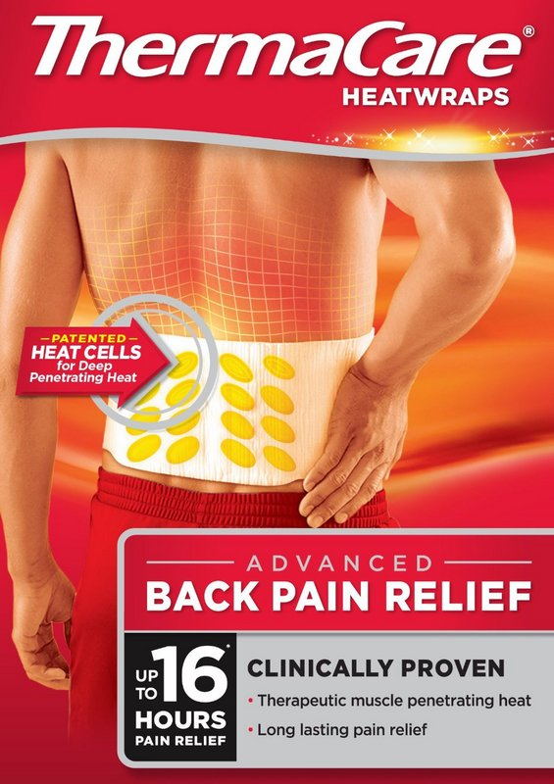

- Essential oil (Pukka) for external use. Massage it softly into the skin of painful area at least 2-3 times a day.

HYDROTERAPHY

- Water treatments should be performed every day, especially alternative heat and ice therapy. It is very effective in easing pain and removing inflammation. Alternative hot and cold treatment will also improve blood circulation, elimination of toxins, will stimulate regeneration, and improve working of the nervous and immune system. Apart from that, it increases the flow of healing oxygen and nutrients to the damaged area, and it suppresses pain signals sent to the brain.
Heat treatment should be cooled with ice. Back pain almost always comes with some level of inflammation, and ice is the best natural way to reduce it. Ice also helps by acting as a local anaesthetic, and by slowing nerve impulses, which interrupts the pain signals in the affected area. Ice, however, should be applied after prolonged hot treatment.
Start with heat first (hot water bottle, electric heating pad, hot shower, hot towel compress, or hot bath) and after about 5 minutes, when the treated area is warm enough, apply an ice pack or any very cold treatment (shower, compress, etc.) for about 3 to 5 min. Then alternate the hot and cold application (3-5 min each), back and forth 5-7 times in a row.

EXERCISES FOR HERNIATED DISC

After you manage to reduce inflammation and pain you should slowly and carefully start the special exercise program using the following YouTube links:

https://www.youtube.com/watch?v=1b1sz3QXeVQ
https://www.youtube.com/watch?v=rdzgJeHYcnQ
https://www.youtube.com/watch?v=wBOp-ugJbTQ

Any appropriate physical activity that gets your blood pumping for a sustained period will release pain-relieving endorphins into your system. Endorphins also help alleviate anxiety, stress, and depression, conditions that often accompany and exacerbate chronic pain.

EXERCISES FOR A THORACIC (UPPER) DISC BULGING
TO PUSH THE DISC BACK IN AND TO IMPROVE STRENGTH, CORE STABILITY, AND FLEXIBILITY

Shoulder Blade Squeezes
Begin sitting or standing tall with your back straight. Squeeze your shoulder blades together as hard and as far as possible pain free. Hold for 5 seconds and repeat 10 times provided there is no increase in symptoms. Repeat 4 - 5 times daily. In some cases it may be beneficial to perform this exercise every 1 or 2 hours provided the exercise does not cause or increase symptoms.
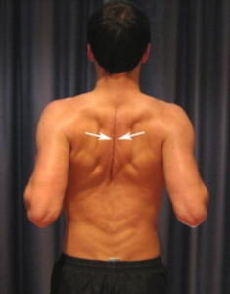

Chin Tucks
Begin sitting or standing tall with your back and neck straight, shoulders should be back slightly. Tuck your chin in as far as you can go without pain and provided you feel no more than a mild to moderate stretch. Keep your eyes and nose facing forwards. Hold for 2 seconds and perform 10 repetitions provided the exercise does not cause or increase symptoms. Repeat 4 - 5 times daily. In some cases it may be beneficial to perform this exercise every 1 or 2 hours provided the exercise does not cause or increase symptoms.
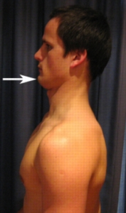

NUTRITIONAL RECOMMENDATIONS

- Discs are composed largely of avascular tissue with a great sensitivity to its nutritional supply and excretion of waste products, and the balance between these two processes is an important factor that could lead to disc degeneration and herniation. It is therefore very important to detoxify the spine and effected area and supply nutrients, phytochemicals and antioxidants through the means of the most beneficial and optimal diet.
The best results will be achieved in this area by implementing key principles of Hallelujah diet (the most effective among all diets) by eating mostly raw plant-based unrefined foods for 3-6 months.

- You will greatly speed up the regeneration of the annulus fibrosus and the recovery from bulging disc by drinking raw fresh cold-pressed vegetable juices (carrots, celery, kale, broccoli, beetroot, etc.): 2 times a day 2 glasses 30 min before meals. To make it easier you can make enough juice for one or two days (not longer than 2 days) and keep it in the fridge. If you don’t like the taste of vegetable juice made out of the mentioned above vegetables you may drink the carrot juice alone.

- Fresh pineapple (bromelain - painkiller). Research shows that bromelain found in fresh pineapples reduces levels of prostaglandins, which are hormones that induce inflammation.

- Use only coconut oil (raw organic). Other fats and plant oils and spreads (margarines, etc.) are high in proinflamatory omega 6 fatty acids. Please keep in mind that especially dangerous are foods which are high in hydrogenated fats and trans-fats such as doughnuts, chips, frozen pizzas, cakes, many bakery goods, etc.

- Eat foods rich in resveratrol (red grapes, cranberries, and blueberries) as it slows down disc degradation. Scientists at Rush Medical University showed that resveratrol blocks the enzyme that is responsible for tissue degeneration.

- Avoid any caffeinated drinks (coffee, black tea, green tea, cola, chocolate, etc.)

- Vitamin K is important in allowing a herniated disc to heal. Found in leafy green vegetables, and soy products as well as in supplements, vitamin K plays an important role in the healing of bones, bone formation and in the synthesis of osteocalcin. Osteocalcin is a bone protein need to crystallize calcium throughout our body. Vitamin K can help to bind calcium to our discs and vertebrae. An injury -- such as a herniated disc -- can cause vitamin K levels to fall. This is because vitamin K binds to the injured site in an effort to help you heal.

- Your diet should contain organic calcium but not from dairy products as although they are high in calcium they weaken bones due to high animal protein content. The healthy sources of calcium are plant foods such as: green-leafy vegetables (kale, etc.), okra, beans, sesame seeds and tahini paste, nuts like almonds, hazelnuts, walnuts, and figs, apricots, tofu, soy bean, etc.

- Eat sulphur rich foods as it accelerates protein and collagen production. Cruciferous vegetables such as broccoli, cauliflower, cabbage, kale, Brussels sprouts, garlic, onion, turnips, are rich sources of sulphur-containing substances known as glucosinolates.

- Avoid dairy products (especially cheese), gluten, processed products, foods high in nitrites (meats), white flour products, white pasta, refined rice, artificial sweeteners, any foods containing high fructose corn syrup, high-glucose syrup, and refined sugar as all of them can exacerbate the inflammation and pain associated with back pain.

- Reduce your intake of grains. Excessive intake of grains and sugars will elevate your insulin and leptin levels primarily through causing your body to be resistant to them, resulting in the increase of inflammatory prostaglandin production.

SHUT DOWN THE CATABOLIC HORMONES (ADRENALIN, CORTISOL)
Learn to control stress through regular exercise, walking outside, meditation (prayer), proper breathing, etc.
Too much stress causes overproduction of adrenalin and cortisol (catabolic or stress hormones) which can be very destructive to the body including spine. Stress is also one of key sources of free radicals which greatly contribute to chronic and degenerative conditions. Apart from stress also diet which is too high in carbohydrates (especially refined ones) can increase blood levels of stress hormones by elevating blood insulin levels.

ADDITIONAL RECOMENDATIONS

- Wear high-heels only occasionally as it is believed it may cause enough additional disc stress to result in further disc bulging.
- Stay mobile, walk, or swim. Avoid positions that increase discomfort such as sitting down.

TESTIMONIES OF PEOPLE WHO RECOVERED FROM HERNIATED DISC

HALLELUJAH DIET
“Dear George and Rhonda, I am excited to let you know that I have experienced healing of my herniated disc as a result of eating The Hallelujah Diet. On September 10, 2006, both of you were in Lexington, Kentucky for a seminar, and I listened intently as Rev. Malkmus enthusiastically shared The Hallelujah Diet. Although I already knew about the diet and thought I was on it, I realized I really wasn’t on it. Hearing your message and talking personally with you both, gave me the motivation I needed to crack down on myself and do The Hallelujah Diet properly and without cheating.
My back pain began in March 2006 when the disk began pinching a nerve going down my leg, which was so painful I was unable to sit. Even during your seminar I had to get up from my chair and go lay down in the back of the auditorium. After the seminar I began eating correctly and drinking lots of carrot juice and within a week I was experiencing much less pain. As of today, I take no pain medication and am able to sit down for long periods of time without pain!
Before going faithfully on The Hallelujah Diet, doctors told me I needed to have surgery for the pain to go away, but I am so happy to let you know that The Hallelujah Diet can even take away the pain of Herniated Discs!” July 10, 2014

“I started The Hallelujah Diet at the insistence of a member of the church I was pastoring at the time. I had severe allergies requiring prescription medication, and an acid reflux problem that had resisted all prescribed medications. After a painful herniated disc erupted in my back, a neurologist prescribed 800mg Motrin for pain. Out of a desperate desire to avoid surgery, I tried The Hallelujah Diet. Within six weeks after changing my diet, I was a new man! Although I don’t always follow the diet as closely as I should, especially in my ministry traveling, I’ve been following the diet for almost three years. I am now free of prescription drugs for indigestion! I sleep through the night without the reflux problems. Other bonuses of The Hallelujah Diet have been a loss of over 30 pounds, increased energy, and the disappearance of those nasty allergies. My back pain mysteriously disappeared, while my strength and stamina returned.” July 14, 2014

“I suffered with lower back problems for a number of years, mainly as a result of a herniated disc. The inflammation was so bad that I was given anti-inflammatory drugs that made me feel very sick. After a daily routine of ice packs, chiropractic visits, therapeutic massage and physiotherapy, I returned to work after a month, continuing my gradual recovery program.
So after much soul-searching and daily cries to God, I begged Him to heal me or take me; I just couldn't bear it any longer. It was at this time that we received a call from some dear friends of ours who sent me an article on Barley green written by Dr. George Malkmus. This truly was a Godsend, an answer to many prayers. I discovered the Hallelujah Diet and continued with the dietary changes I had made, eating more raw fruits & vegetables, drinking lots of distilled water, and I bought a Champion Juicer and began juicing organic carrots.
Immediately after getting off the world's diet I felt worse! This is referred to as the healing crisis. Well I had a couple weeks of these cleansing reactions & then I had some days that I felt better than I had in a long time and within 3 1/2 months all my physical problems were gone, including my back problems! They just slowly disappeared!
Today my diet is approx. 85% raw/15% cooked (some days all raw). Since making the dietary/lifestyle change, my back pain is gone, my bad sinus problems are gone, I have not experienced a head-ache, sore throat, cold, flu, upset stomach.” Randy Rondeau (rondeaur@shaw.ca)

“Hello, I’ve been suffering from disc herniation early May 2014. I’m in pain daily, all day. Could you share more about your experience with healing your disc? How long did it take to heal? What did you eat and drink? I’m really desperate as I’ve tried physical therapy, chiropractor and now non-surgical spinal decompression. I started acupuncture this past Monday. I do not want to have back surgery but I really don’t know much more of this pain I can take.” Tiana, September 11, 2014
“Hi Tiana, After desperate attempts like you I resorted to taking anti-inflammatory meds as a band aide to help with the pain as I dug myself out of the disaster. I went cold turkey and did a 3 day alkaline juice feast as on my site under Juice feast- search it on my site. Then I only ate alkaline blended or raw foods and green juices for 3 months plus a bit of legumes after 6 weeks and I was then finally completely out of pain! It was like a miracle that it worked from my uneducated nutritional perspective! When I was in it, it felt like it was never going to end and that 3 months was an eternity! But I have to say, changing my lifestyle has been permanent relief with no side effects except good ones like vibrant health and weight loss and loving life! I am ever grateful for my herniated disc and that it lead me here! Please read Dr. Robert O. Young’s book The pH Miracle Revised. It helps keep you motivated when you educate yourself and it will answer many questions.
Most of all, drink lots and lots of clean pure alkaline water! This will plump the disc up! Gosh I want you to have faith, because this truly is the way. Don’t get the surgery, you’ll regret it later! It’s the quick fix from the outside. You need to heal from the inside out! All my best! And please please, let me know your success and how you are doing!!! YOU CAN DO IT!” Julie, September 11, 2014
“Hi Julie, I have just started eating the alkaline way and I’m reading The ph Miracle book at the moment, even after just a few weeks of changing my diet I feel so good, lots more energy and just feel better within myself, I have been suffering a lot of health problems over the years and I am glad I have found out about this way of healing my body from the inside out.” Karen, September 20, 2014

CHLORELLA
“My husband, who was suffering from a herniated disk, began to take chlorella along with me about 2 years ago. He had severe pain, and once he sat down, he had a difficult time getting up. Now he is free of any pain and is able to get up smoothly. Furthermore, when our eldest daughter was suffering from herpes zoster after giving birth, we let her take chlorella, and she recovered from herpes zoster. I am confident that it was chlorella that helped our family.”

“I have been taking Chlorella for several years. I had a herniated disk in my back. I am better now. I've told other family members to try them. I will continue taking them till I find they don't help me.” Henrietta W. Regina, SK

SERRAPEPTASE
“I have a herniated disc and hyperplasia in my hips. I'm 45 and have been in constant pain for the last three years. I refuse to use NSAIDS or narcotics anymore, and over the years have tried all kinds of treatments including chiropractic, physio, herbs, massage, etc. with no success. However my local health food store sells Serrapeptase and they recommended it. I took my first 60mg Serrapeptase capsule last week and within an hour my pain was radically diminished. I increased the dose to two capsules in the morning, and one at night, if needed. So after my first week, I can honestly say my pain is gone! I haven't been pain free in three years.” Jemma Lee, Victoria, BC CA
“At the moment I am dealing with inflammation in shoulder, muscle tears, and a herniated disk. The serrapeptase has really been making a difference. I started with 6 tablets (50,000 IU) 3 x a day. When I backed off to 3 tablets 3 x a day I noticed the difference and so increased it again these last few days. It has made these days much more comfortable and more movement possible.”
“One thing to try is serrapeptase. It's been prescribed in Europe and japan for years. I just started taking it and feel good, tweaked my back a few weeks ago. It works as a safe anti-inflammatory, with no side effects. Take it on an empty stomach as it breaks down in the intestine.”
“I have been using serrapeptase for about 3 weeks because of a partially degenerated disc in my lower back. Just two days ago my pain has subsided, and I find it unbelievable. The pain that I was experiencing was just almost unbearable! I was living on ibuprofen but now, I really do not need it.” VM
“I’ve suffered from neck pain for the last 42 years from 6 different injuries. Serrapeptase has given me the most relief of anything I’ve tried. I still have pain but it’s greatly reduced from what it is was before.” E.W.
“Serrapeptase is better than a cortisone shot. I have tennis elbow and I used to have to take cortisone shots. Now the pain in my elbow, knees, wrists, and ankles is gone. I started with 4 tablets 3 times daily then I reduced to 3 tablets 3 times daily. If I take less than that I notice some pain in my joints. My ankle swelling is gone now and it looks like someone else with skinny ankles is wearing my shoes. My haemorrhoid disappeared. It had been my friend for 30 years but I don’t miss it one bit. Also my blood pressure is down 10 points. I recommended it to my brother and he said it took 2-3 weeks for his joint pain to go away.” PC
“I have been in pain for so long I can’t remember when I wasn’t until now. My doctor asked me to take serrapeptase hoping to get me off Celebrex and to keep me from going on narcotics for relief of my pain. I took three serrapeptase yesterday three this morning and three more just a while ago. The pain I have felt for so long is gone. I can run and walk without pain of any kind. This has renewed my life and made it a joy to get up in the morning and thank God for another day.” BV
“Serrapeptase works like magic for osteoarthritis. I have a severe case of it. I do not take any other anti-inflammation drug or any pain killer.”
“My mother has been taking serrapeptase and now she is walking without her walker. She says she feels a lot better. I gave a bottle of serrapeptase to a man in his late 70′s and he got improvement in 3 days. He said his back doesn’t hurt anymore.”
“Since I started taking serrapeptase in July I’ve lost 36 pounds and 4 inches off my waist. People who haven’t seen me in a while don’t even recognize me. I had been taking Motrin, two 800mg pills 3-4 times daily and now most days I don’t even need to use it at all.” MS
“I would wake up at night with such severe pains in my head that I thought about putting a gun to my head. I read about serrapeptase and bought some and it has given me great relief. It’s a miracle; it honestly, truly is. It has made a believer out of me. I noticed the biggest difference when I increased the dosage to 3 tablets 3 times per day.”

EXERCISES
“I had a heavy bulge in May 2013, I was on bed for 8 months as i couldn't sit for more than 1 hour continuously or walk for more than 100 meters. I tried many things and not a lot of improvement. But I got a set of exercises which gives exercise to all body muscles which worked brilliantly for me. Within 6 months here I am with no pain, able to walk as much as possible and I can dance too!”
“I am now extremely aware of always bending my knees instead of leaning over with knees locked. I have done some YouTube bulge disc exercises and had no pain after 5 months of pain. Lots of icing seems to be the best for pain relief. I had another relapse this weekend after going on long walks this week but I should have avoided hills.”
Diet and lifestyle according to the HEALTH RECOVERY PLAN

